**Bespoke Bedroom Wardrobes: The Perfect Blend of Style, Functionality, and Personalization**

Introduction

In today’s world, bedroom storage is no longer limited to generic, pre-made closets that may not fit your unique space or style. Bespoke bedroom wardrobes offer a tailored solution that combines function, aesthetics, and personalization, allowing you to create the perfect wardrobe that fits your room’s layout and meets all your storage needs. From maximizing storage in compact spaces to designing luxurious walk-in wardrobes, bespoke wardrobes are the ultimate choice for a beautiful and organized bedroom [fitted wardrobes london](https://rancolondon.co.uk/bedrooms/).

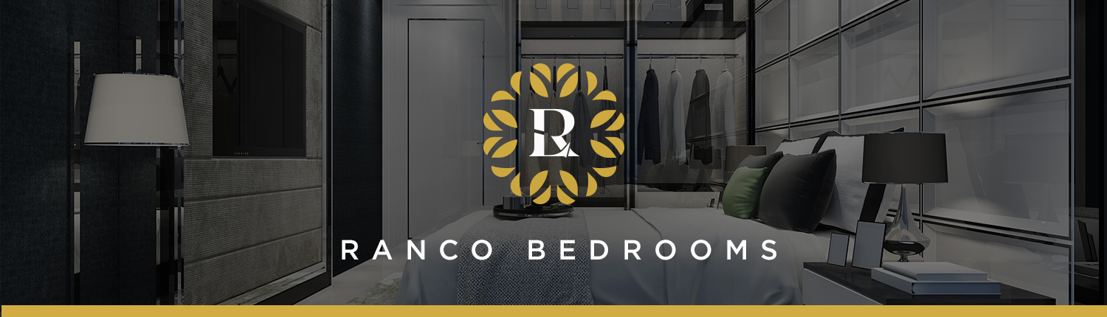

1. Why Choose a Bespoke Wardrobe?

Bespoke wardrobes are custom-built, meaning they are specifically designed to fit your room’s dimensions, style, and personal preferences. Unlike standard wardrobes, which may waste valuable space or clash with your decor, bespoke wardrobes fit seamlessly into any room, making use of every inch. This adaptability is particularly valuable in homes with unique layouts, sloped ceilings, alcoves, or irregular wall shapes. Bespoke wardrobes also allow you to design a piece that matches your bedroom's overall theme, providing both aesthetic value and functional storage [bespoke bedroom wardrobe](https://rancolondon.co.uk/bedrooms/).

2. Maximizing Space and Functionality

One of the primary benefits of a bespoke wardrobe is its ability to maximize space efficiently. In a small bedroom, a customized wardrobe can provide much-needed storage while avoiding the bulky feel of standard wardrobes. For example, you can design narrow hanging spaces, slim pull-out drawers, or high shelves to store seasonal items, ensuring no part of the wardrobe is left unused. Conversely, for a large bedroom, a bespoke wardrobe can be designed as a spacious, luxurious walk-in closet with separate sections for clothes, shoes, accessories, and even integrated lighting. This level of custom design ensures that every inch is used in a way that fits your unique storage needs and lifestyle [fitted loft wardrobes](https://rancolondon.co.uk/bedrooms/).

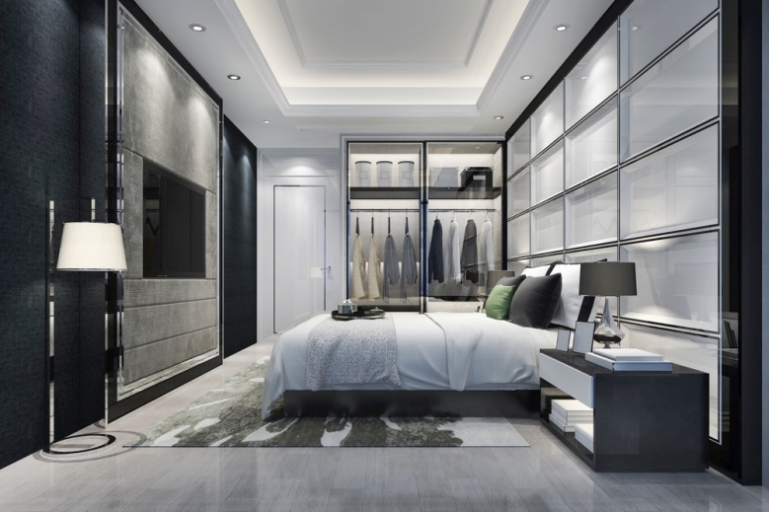

3. Personalized Interiors for Practical Use

Bespoke wardrobes offer countless customization options for the interior layout, ensuring everything is stored exactly where you want it. You can specify how much space you need for hanging clothes, folded items, shoes, or accessories, tailoring the interior to meet your specific requirements. Some popular options include adding pull-out shoe racks, jewelry trays, tie holders, built-in mirrors, and even laundry hampers. You can also incorporate adjustable shelving and custom-sized drawers to provide flexibility as your needs change. This customization not only optimizes functionality but also makes it easier to keep your belongings organized and accessible [fitted walk in wardrobes](https://rancolondon.co.uk/bedrooms/).

4. Aesthetic Versatility: Choose Your Style and Finish

When it comes to design, bespoke wardrobes offer unmatched versatility. You can choose from a range of materials, colors, finishes, and styles to create a wardrobe that matches your bedroom’s decor. Whether you prefer a modern, minimalist look with sleek lines and neutral colors, or a more classic style with wood finishes and ornate detailing, bespoke wardrobes can be crafted to your exact taste. High-quality materials such as solid wood, glass, or mirrored surfaces add luxury and durability, while custom finishes like matte, gloss, or textured options bring sophistication to the overall design. This freedom to select your materials, colors, and style makes your wardrobe a personalized and cohesive part of your room [fitted sliding door wardrobes](https://rancolondon.co.uk/bedrooms/).

5. Adding Value and Durability to Your Home

Investing in a bespoke wardrobe adds lasting value to your home. Unlike mass-produced wardrobes, which may need to be replaced over time, bespoke wardrobes are built with high-quality materials and skilled craftsmanship, ensuring durability and longevity [cnc cutting london](https://rancolondon.co.uk/cnc-cutting/). Properly maintained, they can retain their appeal for decades, adding both practical and aesthetic value to your home. If you decide to sell your home, a well-crafted, custom wardrobe can be a unique selling point, enhancing the property’s appeal to potential buyers and highlighting the thoughtful attention to detail in your home design [cnc cutting service london](https://rancolondon.co.uk/cnc-cutting/).